 | EUROMECH Colloquium 678: Frontiers in Non-Smooth Dynamics  29 November – 1 December 2027, Exeter, UK

Title of the Abstract (Max Two Lines)
A. Author¹ (PhD Student), B. Author¹, C. Author¹
¹ Affiliation, Country
Presenter: A. Author
Corresponding author: C. Author (email@domain)

Keywords: Please provide 3-5 keywords relevant to your contribution.
Write your abstract here. Keep the total length to one page including any figure and references. Example inline citation [1].
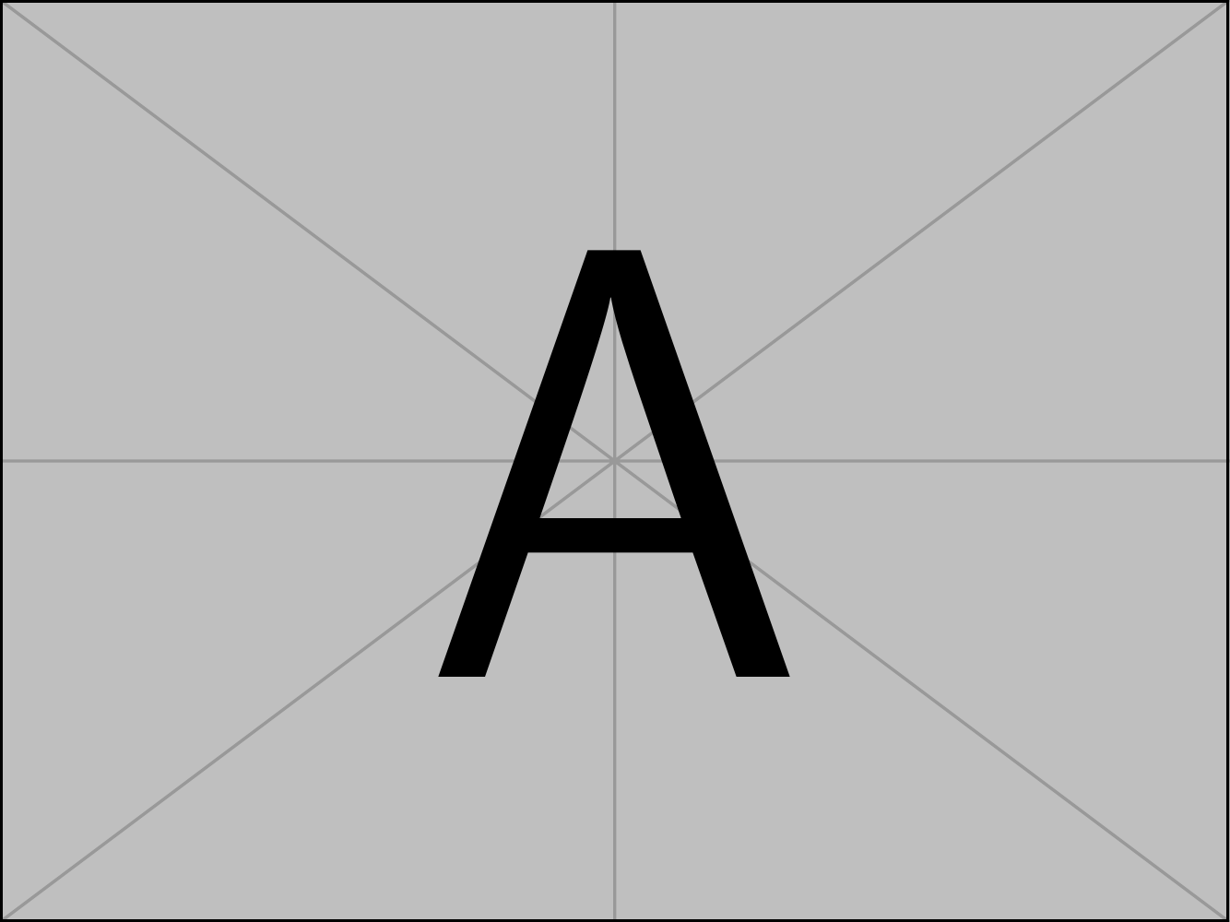
Figure 1: Example of figure (optional).

Page limit: ONE (including any figure and references).

References
[1] Title. Journal, xx-xx, year.

